LAB REPORT

for
Lab Assignment #6:
Settable Digital Clock with Seconds Display

Table of contents:

1. Introduction………………………………………………………………….………..1

2. Design ………………………………………………………………………………..1

3. Functional Behavioral Requirements……………….………………………….…..1

4. Prototype Testing Plan…………….………….…………..…………….....………..2

5. Answer To Questions…...………………………………………………….………..2

……………………………………………………………3

……………………………………………………………4

6. Conclusion………….……………………………………………………….………..5

1. Introduction

“In this assignment, students will create a modular sequential logic design using VHDL, to implement a simple digital clock application displaying hours, minutes, and seconds, and that includes an interface to allow the user to set the current time. This assignment is to be carried out as a structured design process. Students should design and test their circuits at home in the simulator, and then test their designs in lab on the boards.”

-- quoted from Lab Assignment #6 document.

2. Design
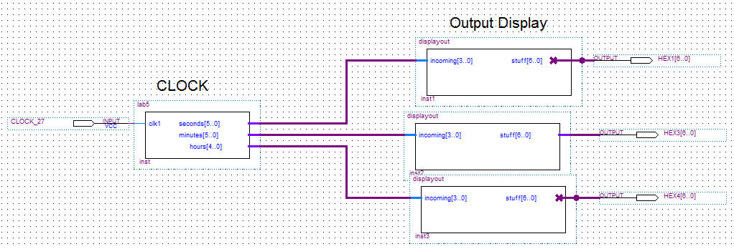

3. Functional behavior requirements

System-level functional requirement #1. User can set the hours and minutes by pressing a button.

System-level functional requirement #2. User can reset the seconds to 0 by pressing a button.

4. Prototype testing plan
The testing procedure consists of the following steps:

1. Turn the DE2 board on. The initial time should be 00:00:00.

2. Press the hour’s button. Test if it increments correctly.

3. Press the minute’s button. Test if it increments correctly.

4. Press the second’s button. Test if it resets to 0 correctly.

5. Monitor and observe the circuit for 5 minutes.

5. Result of Testing
We first analyzed and compiled our circuit. Then we ran it. There was weird output, and no counter working. The problem was an input pin with the wrong name (CLOCK_27). Then we recompiled and ran it again. The time and rollover worked for minutes and seconds, but the hour display wasn’t working. So we then VCC’d the extra HEX1 and HEX0. The buttons we malfunctioning too; when pressed, they would output an increment or reset (for seconds), but it wouldn’t change the counter; it still ran in the background. We then increased the speed of the clock for testing purposes. After we ran it again, it was faster and the extra HEX displayed were turned off; both as expected. The only problems left were the display for hours and the buttons. After much change in the code, the problem was the sequence of our nested if statements. So we lastly slowed the time back down and resulted in a working digital clock with increment and reset buttons.

6. Questions

Question #1.
Above is the overall system architecture

Question #2.
What will be used for the time reference will be the clock oscillator built into the DE2 board. It runs at a frequency of 50 and 27 MHz. The name of its FPGA input pin is CLOCK_50.

Question #3.
The oscillator will pass between display updates 27 times since the reference oscillator is 27Hz. A clock-divider counter will be needed, and it will be 6 bits larger because 59 is 6 bits.

Question #4.
Because time has a lot of roll over, this must be taken into account. Every time the seconds, hours, and minutes reach their peak (59,12, 59), they must start back at 1 and increment.

Question #5.
The input devices on the DE2 board that will be used to manual set the time will be the KEY’s. There will be two buttons (one for hours and one for minutes). Each button will increment the minute/hour when pressed. There will be a third button that resets the seconds to zero.

Question #6.
Below is the VHDL.. for output and clock.

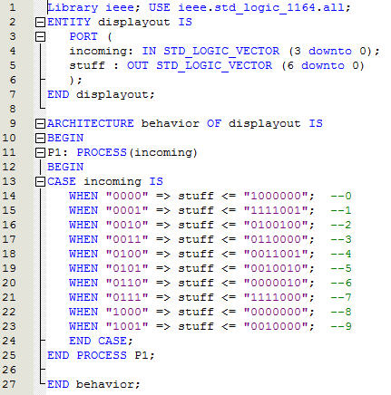
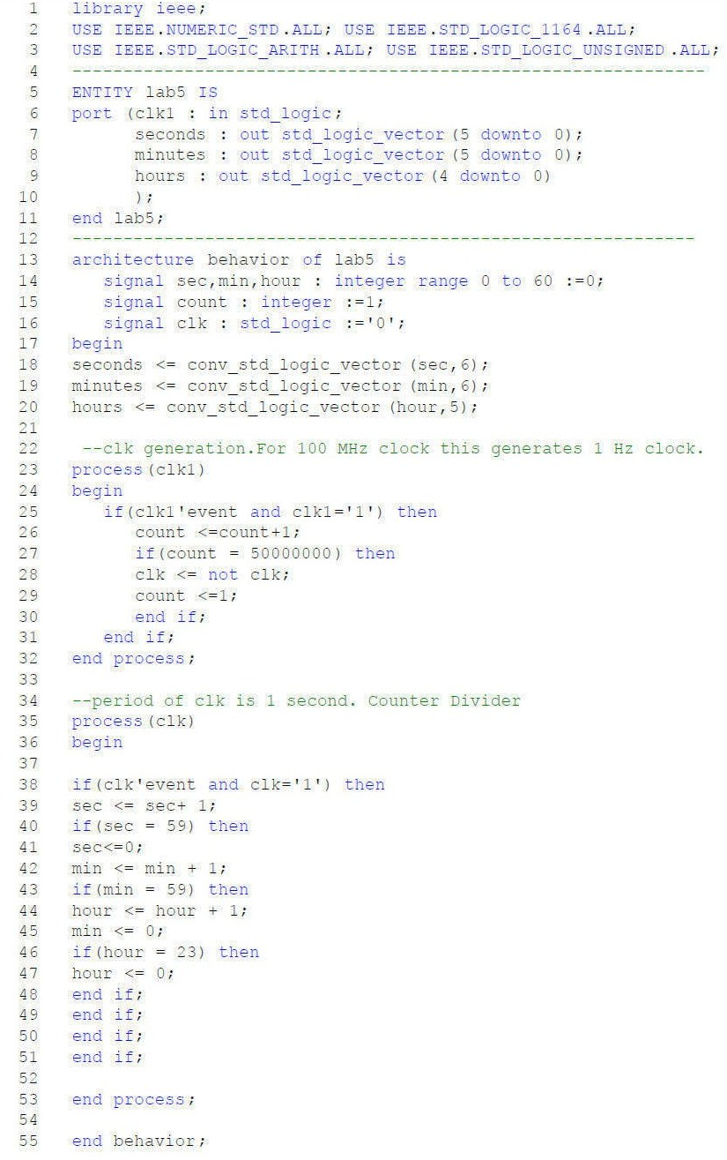

Question #8.
The prototype testing will include these steps.
1. Turn the DE2 board on. The initial time should be 00:00:00.
2. Press the hour’s button. Test if it increments correctly.
3. Press the minute’s button. Test if it increments correctly.
4. Press the second’s button. Test if it resets to 0 correctly.
5. Monitor and observe the circuit for 5 minutes.

6. Conclusion
This assignment was intended to give practice at design & coding of modular sequential designs in VHDL using behavioral coding with process statements. Also, it was intended to exercise our understanding of basic modular sequential elements such as counters. The lab assignment also gives practice at programming, simulating, and debugging modular sequential HDL-based designs using the Quartus tool. Lastly, this assignment continued exercising our ability to go through a structured design process with all appropriate documentation.

